**Medium and Short Transmission Line**



**Javier Jesús Macossay-Hernández**

**EE443 – Introduction to Power Systems**

**University of Southern California**

**Professor Robert Castro**

**Objective**

In power engineering, different transmission lines models are used to do system analysis. Depending on the length of the transmission line is the model used for it. Short model is from 0 miles to 50 miles, Medium or pie model ranges from 50 miles to 150 miles, and long model is larger than 150 miles.

**Introduction**

Through a PowerWorld example and the use of the ABCD two-port network models as the line, the short and medium line model will be discussed. A medium length model is sufficiently accurate even for lines greater than 150 miles. Nevertheless, PowerWorld uses the actual model for transmission lines and gives precise results. We will compare manual calculation results with PowerWorld results.

**Methods**

For this problem, the transmission line runs from DAVIS69 to SCOT69, Figure 1.

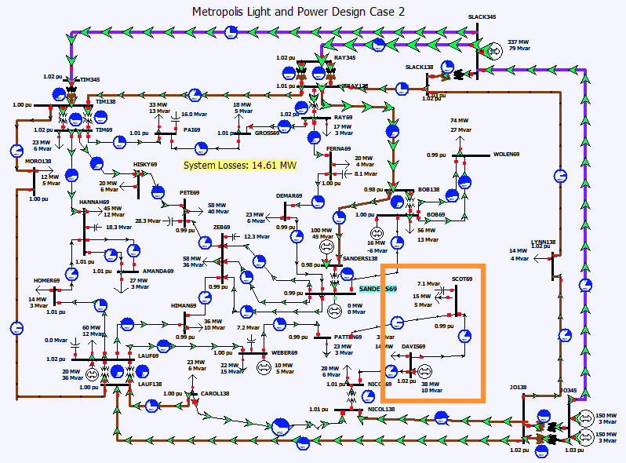

Figure 1: The overall schematic of the circuit is shown, where the transmission line from DAVIS69 to SCOT69is highlighted.

**Calculations**

Data of the system will be needed to estimate the ABCD parameters, which is found in PowerWorld. From the branch of information seen below, the p.u. value of the total impedance and admittance of the transmission line is obtained. Z = 0.021396+j0.07509 p.u. and Y = j0.0008 p.u

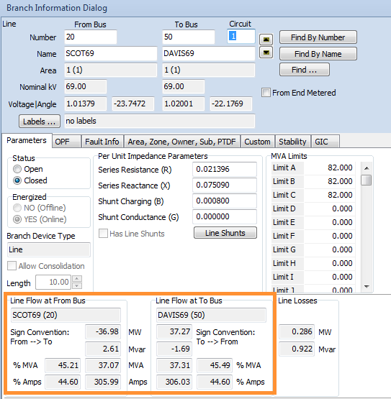

Vs = 1.02<-22.18 p.u. and Vr= 1.014<-23.75 p.u. Also, Is= 306.03 A and Ir = 305.99 A. Ps = 37.27 MW and Pr = 36.98 MW. It is important to notice that the receiving end power factor = ∅r = 1 because the reactive power is not being consumed.

The actual values of the line impedances and admittances from the run mode cannot be found. In addition, the length of the transmission line cannot be seen. Therefore, the information will be gathered from the information dialog from the edit mode.

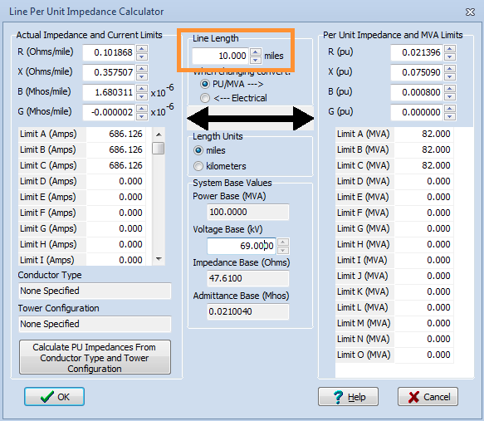

The length of the line as 10 miles, which is a short transmission line, is given by the following process. Hence, the short line model will only be used for this case and the results will be compared with the aforementioned PowerWorld data. Sbase = 100 MVA, kVbase = 69kV and Zbase = 47.61

The base value for the current will be calculated with the information from the line per unit impedance calculator.

Ibase = = = 836.74 A

*Short Line Model*

Next, the short line model will be depicted. The shunt admittances for the short line model will be neglected.

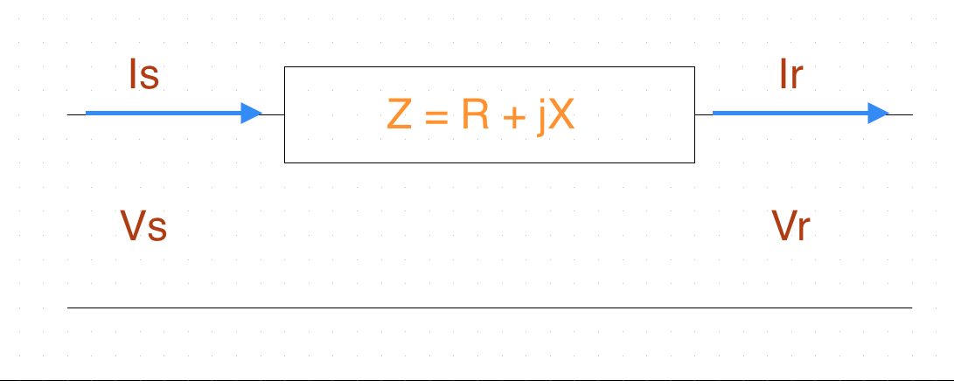

Vs = A*Vr + B*Ir

Is= C*Vr + D*Ir

For a short line model,

A = D = 1

B = Z = 0.021396+j0.07509

C = 0

Therefore,

Vs = Vr + Z*Ir

Is= Ir

Now, the Ir will be calculated with the PowerWorld values for Vs, Vr, and Z

1.02<-22.18 = 1.014<-23.75 + (0.021396+j0.07509)*Ir

Ir = 0.3651 < -2.371pu

And we know that Ibase = 836.74 A, where I pu = $\frac{I actual}{I base}$

Therefore, Ir actual = 0.3651 * 836.74= 305.49 A

Is = Ir = 305.49 A

According to the PowerWorld simulation, Ir = 305.99 A and Is = 306.03 A. In the simulation, Ir and Is have different values because the short line model is not being used. In addition, the shunt parameters are taken into account. The results are similar to the PowerWorld results with an estimated error of (305.99 – 305.49)/305.99 = 0.16%

*Medium Line Model*

To study the medium line model, the length of the same transmission line should be changed from 10 miles to 120 miles in edit mode. The data will be gathered from PowerWorld.

The p.u. value of the total impedance and admittance of the transmission line are obtained from the branch information dialog shown below.

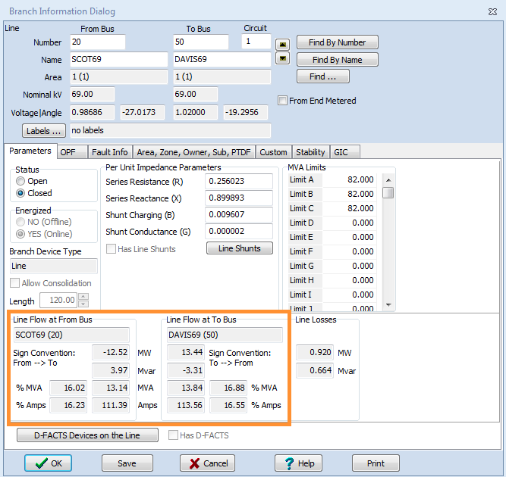

We get Z = 0.256 + j0.89989 p.u. and Y = j0.0096 p.u. Vs = 1.02 <-19.29 p.u. and Vr= 0.986 < - 27.02 p.u. Also, Is= 113.56 A and Ir = 111.39 A. It is important to notice that the receiving end power factor = ∅r = 1 because the reactive power is not being consumed.

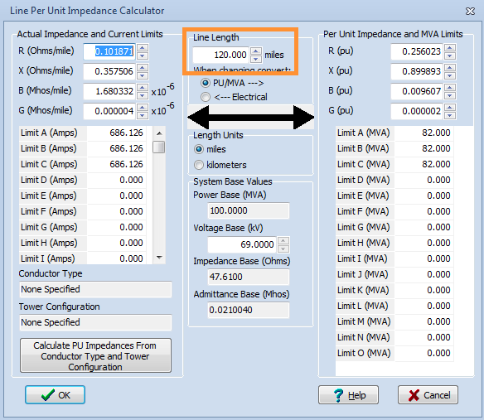

This length of the line is now 120 miles, which means it is a medium length transmission line. Moreover, the aforementioned model will be used for this case and it will be compared to the PowerWorld simulation data. Sbase = 100 MVA, kVbase = 69 kV and Zbase = 47.61. The base current value is:

Ibase = = = 836.74 A

Next, the medium line model will be depicted. The shunt admittances for the medium line model will be neglected.

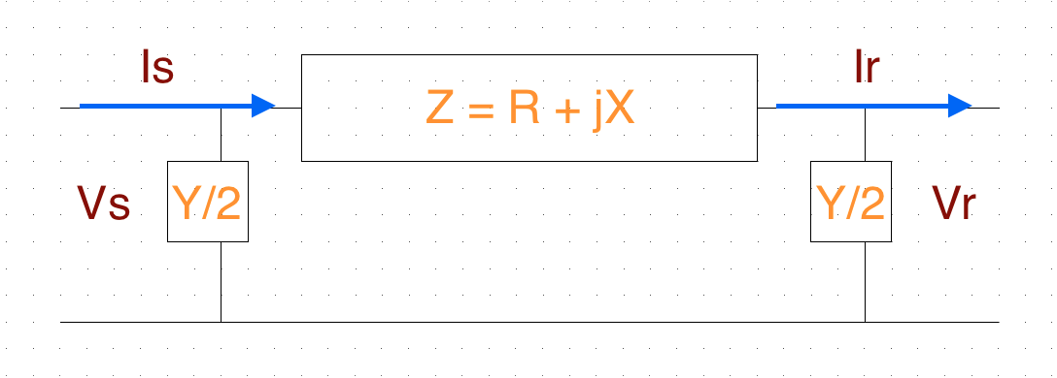

Vs = 1.02 < -19.4293

Vr = 0.99 < -26.9

Z = 0.256 + j0.89989

Y = j0.0096

Vs = A*Vr + B*Ir

Is= C*Vr + D*Ir

For a medium line,

A = D = 1 + (ZY)/2 = 1 + [(0.256 + j0.89989) * (j0.0096)]/2 = 0.99568 < 0.0707

B = Z = 0.256 + j0.89989 = 0.9356 < 74.12

C = Y * (1 + (ZY)/4) = (j0.0096) * (1 + ((0.256 + j0.89989) * (j0.0096))/4) = 0.009579 <-89.96

Substituting Vs = A*Vr + B*Ir

1.02 < -19.4293 = (0.99568 < 0.0707) * (0.99 < -26.9) + (0.9356 < 74.12) * Ir

where Ir = 0.1431 < 22.05 pu

And we know that Ibase = 836.74 A, where I pu = $\frac{I actual}{I base}$

Therefore, Ir actual = 0.1431 *836.74= 119.737 A

By the same argument,

Is = (0.009579 <-89.93) * (0.99 < -26.9) + (0.99568 < 0.0707) * (0.1431 < 22.05) = 0.135 <19.49

Is actual = Is pu * Is base = 0.135* 836.74 = 113.033

In theory, it should give me an answer that is closer to the simulation, but in reality the transmission line is not isolated as in the calculation. As a result, every single time I run the calculation I will get a slightly different answer, which can be seen in the following images.

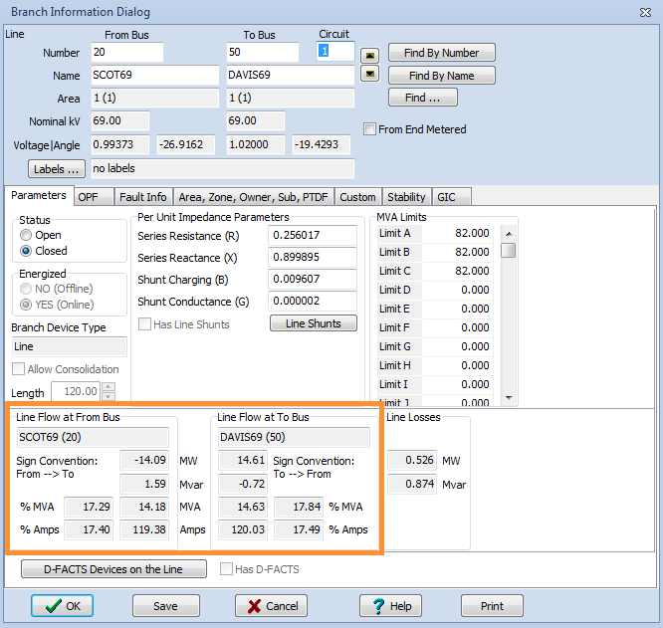



**Results:**

Thus, it was observed that PowerWorld gave the exact answers without taking into account the length of the line. Medium line model was very efficient for analysis purpose. ABCD parameters can be effectively calculated from the data obtained from the PowerWorld. The values given by PowerWorld by manual calculations were verified and they got a diminutive value for the error.

**Discussion**

An error between the simulation and the hand calculation can be produce when doing the medium line model. There are several lines connected with the selected transmission line. Therefore, the sending current “Is” may vary from the calculation performed when isolating the transmission line and doing hand calculations. In reality, I will never get the exact same value because the part selected for analyzing will always be influences by the whole system.